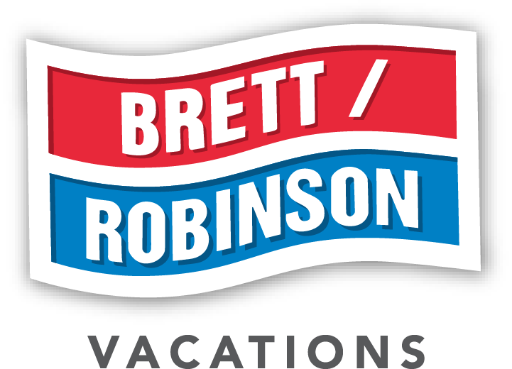

Meeting Room & Event Space Reference Guide
Gulf Shores & Orange Beach, Alabama | June 2026

About Brett Robinson Vacation Rentals
Brett Robinson Vacation Rentals is the Gulf Coast's largest locally owned vacation rental and property management company, with an extensive portfolio of suites and condominiums across Gulf Shores and Orange Beach, Alabama. For more than 40 years, guests have trusted us to deliver outstanding customer service, southern hospitality, and local knowledge with a hands-on, personal touch. Our group sales team specializes in building special experiences at our Phoenix properties for groups of every size — from intimate corporate board meetings to large-scale conferences, weddings, family reunions, sports teams, church groups, and social organizations.

Our group sales team works directly with group coordinators, meeting planners, and event organizers to create a seamless Gulf Coast experience. All inquiries and communications are routed through our dedicated group email so we can assign the right team member and build a personalized solution for your group.

Why Book with Brett Robinson?
- Largest locally owned portfolio on the Gulf Coast — hundreds of suites available for group blocks
- 24 dedicated meeting and event rooms across 14 Phoenix properties in Gulf Shores and Orange Beach
- Dedicated group sales team providing personalized service from inquiry through checkout
- Flexible catering — all properties allow you to bring the catering partner of your choice
- A/V equipment available at select properties at nominal cost
- Group discounts available on qualifying stays (see Discount Policy below)
- Competitive shoulder-season rates ideal for corporate retreats, church trips, and civic groups
- Complimentary beach ceremony location provided for qualifying groups. Ceremony rentals and services—including chairs, arches/altars, decorations, and officiant services—are available from multiple vendors.

Meeting Room Capabilities & Rates
Property | Dimensions | Sq Ft | Theater | Classroom | U-Shape | Hollow Square | Banquet* | AM Rate† | PM Rate† | Full Day†
Phoenix I | 21 × 11.8 | 500 | 35 | 16 | 16 | 16 | 25 | $60 | $60 | $100
Phoenix I | 21 × 40 | 800 | 60 | 44 | 20 | 20 | 40 | $90 | $90 | $150
Phoenix II | 21 × 40 | 800 | 60 | 44 | 20 | 20 | 40 | $90 | $90 | $150
Phoenix III | 21 × 40 | 800 | 60 | 44 | 20 | 20 | 40 | $90 | $90 | $150
Phoenix VI | 20 × 23 | 500 | 25 | 18 | 12 | 20 | 25 | $45 | $45 | $75
Phoenix VI | 23 × 60 | 1,530 | 100 | 75 | 30 | 40 | 60 | $120 | $120 | $200
Phoenix VII | 20 × 23 | 500 | 25 | 18 | 12 | 20 | 25 | $45 | $45 | $75
Phoenix VII | 23 × 60 | 1,530 | 100 | 75 | 30 | 40 | 60 | $120 | $120 | $200
Phoenix IX | 18 × 28 | 500 | 15 | 12 | 10 | 15 | 16 | $45 | $45 | $75
Phoenix IX | 48 × 59 | 2,970 | 150 | 75 | 20 | 20 | 80 | $150 | $150 | $250
Phoenix X | 23 × 60 | 1,530 | 100 | 75 | 30 | 40 | 60 | $120 | $120 | $200
Phoenix West | 50 × 10 | 500 | 25 | 16 | 12 | 16 | 24 | $75 | $75 | $150
Phoenix West | 104.5 × 48.5 | 4,425 | 200 | 150 | 30 | 40 | 200 | $500 | $500 | $750
Phoenix West | 104.5 × 48.5 | 3,950 | 200 | 150 | 30 | 40 | 200 | $500 | $500 | $750
Phoenix Gulf Shores | 30'8" × 61' | 1,860 | 100 | 50 | 30 | 30 | 60 | $400 | $400 | $750
Phoenix Gulf Towers | 30'8" × 61' | 1,860 | 100 | 50 | 30 | 30 | 60 | $400 | $400 | $750
Phoenix Gulf Towers | 30'8" × 61' | 1,860 | 100 | 50 | 30 | 30 | 60 | $400 | $400 | $750
Phoenix East | 23 × 60 | 1,530 | 100 | 75 | 30 | 40 | 60 | $120 | $120 | $200
Phoenix on the Bay | 20 × 30 | 1,275 | 50 | 32 | 15 | 20 | 50 | $120 | $120 | $200
Phoenix Orange Beach | 30'8" × 61' | 1,860 | 100 | 50 | 30 | 30 | 60 | $400 | $400 | $750
Phoenix Orange Beach | 30'8" × 61' | 1,860 | 100 | 50 | 30 | 30 | 60 | $400 | $400 | $750
Phoenix Orange Beach | 30'8" × 61' | 1,860 | 100 | 50 | 30 | 30 | 60 | $400 | $400 | $750
Phoenix Orange Beach II | 30'8" × 61' | 1,860 | 100 | 50 | 30 | 30 | 60 | $400 | $400 | $750
Phoenix Orange Beach II | 30'8" × 61' | 1,860 | 100 | 50 | 30 | 30 | 60 | $400 | $400 | $750
Phoenix Gulf Shores II | Coming Soon

* Banquet capacity shown reflects banquet-table setup. Banquet-rounds capacity may differ.
† AM = 8am–2pm | PM = 4pm–10pm 2pm | Full Day = 8am-10pm. April–September rates are charged per day. October–March rates are charged per stay (3 Days Max) at most properties (Phoenix West, Phoenix Gulf Shores, Phoenix Orange Beach, and Phoenix Orange Beach II remain per-day year-round).
Maximum capacity shown per setup. A $250 setup fee applies at all properties. Events at Phoenix West with 75 or more attendees require licensed security

Meeting Room Rental Requirements

Condo Rental Requirement
- A minimum of 5 condos or beach houses must be rented through Brett/Robinson
- Groups who do not meet the rental requirements will be charged a $250 non-refundable administrative fee for meeting room use

Group Discounts
Group discounts apply to stays that include 5 or more units booked together for the same period. Discounts are applied to the nightly rental rate.

Season / Period | Discount | Notes
Summer Season (June – August) | 5% | Applies to qualifying group stays of 5 or more units
Shoulder Seasons (Spring & Fall) | 10% | Applies to qualifying group stays of 5 or more units
- Group Discounts are not available for stays that include July 4th, Labor Day, Memorial Day, or Shrimpfest.

Parking for Event Attendees
Parking availability and any associated charges for attendees who are not staying at the property are determined case-by-case based on building occupancy at the time of the event and the duration of the event. Groups should discuss parking needs with our team at the time of booking.

Request a Proposal
All group inquiries are handled through our dedicated group sales email. Once received, we will assign a team member who will contact you to build a personalized solution for your group.

Email: groups@brettrobinson.com
Group Sales Team: Roz Shoots | Linda Alderman

Rates, capacity figures, and availability are subject to change. Contact the group sales team for current information and formal proposals.

